ITRG Scope of Work

Data Replication

Author: Yin Hui 22 Dec 2016

Version 1.0

# Introduction

The entities in this document refer to the company databases to be setup in SAP Business One. The setup will be done in the **Target entity**.

Replication will be triggered from the **Source entity**.

ITRG requires the following master data to be replicated:

* Exchange rate (Singapore Entities)
* Chart of Accounts
* Item Code
* Supplier Master
* Supplier Price List
* BoM (Recipes)

# ITRG Replication – General Setup

Each entity (Target database) will have a setup table to indicate the source database to copy the master data from. When master data is being created or updated in the source database, the entity will be updated with the delta changes automatically without human intervention.

**Deletion will not be replicated.** This is because an item can be created in the source database and replicated to the target databases. This item may not be used in the source database, but may have been used in the target databases. Hence any automatic deletion replication may be fail in the target database. If the user recreates the deleted item with a different purpose, this may conflict with the item transaction that failed to be deleted in the target database.

**Exception Reports** instead will be proposed to assist users in executing deletions. Users can base on the transactional status of the items created to decide which items can be deleted across every source and target databases.

The following screens are part of the SAP Business One customized intercompany module.

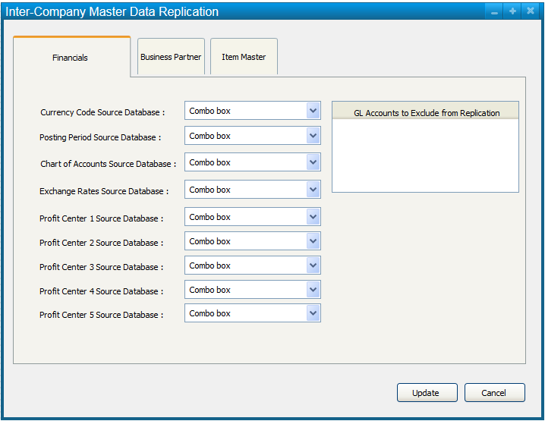

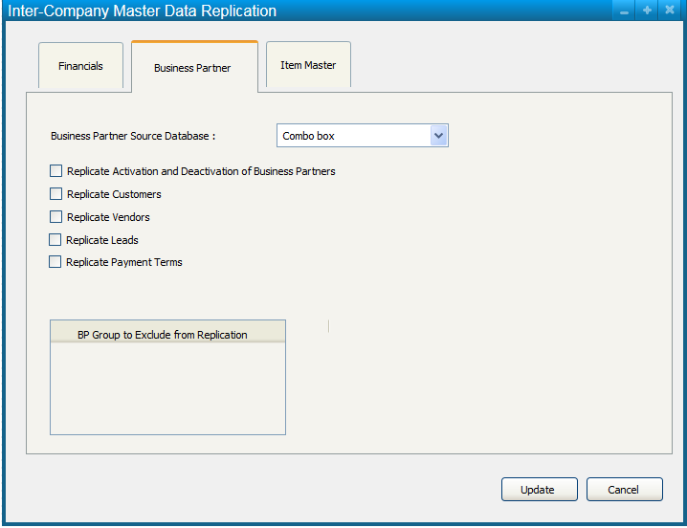

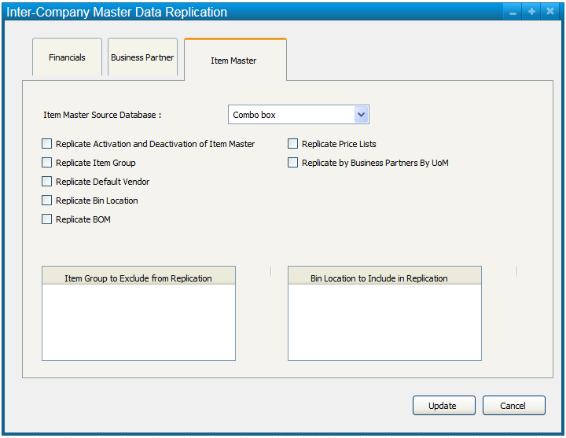

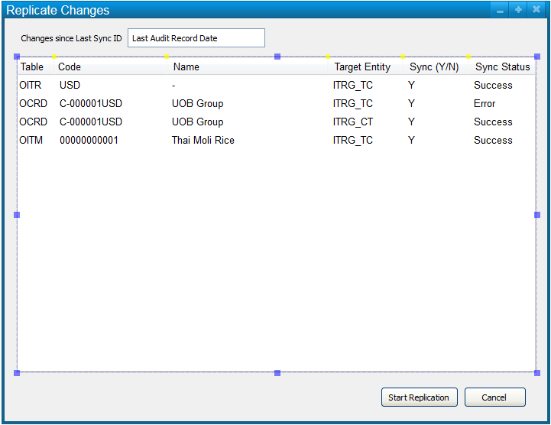

Changes replicated will be saved to integrationDB. For records that are excluded from the replication will be marked as ‘N’.

Integration DB Table

|  |  |  |  |  |  |  |  |  |
| --- | --- | --- | --- | --- | --- | --- | --- | --- |
| Table | AuditID | Code | Name | SourceDB | TargetDB | Sync  Y/N | Sync  Status | Sync DateTime |
| OITM | 100023 | 00000001 | Cheese | ITRG_HQ | ITRG_CT | Y | Success | 20161201 255pm |
| ORIT | 2319 | USD |  | ITRG_HQ | ITRG_CT | Y | Err, Code not exists | 20161201 255pm |
| OITB | 4817 | 119 | Online | ITRG_HQ | ITRG_CT | N |  |  |

User can rectify the error in target db and click “Start Replication” to retry again for the failed records.



User Process Flow for Replication

# replication setup – Financials



* Currency Code and Chart of Accounts can be replicated or updated if already exists.
* GL accounts in the exclusion list will not be replicated.
* Posting Period can be replicated if the starting date of the next fiscal period in the target entity is the same as the source entity.
* The exchange rates can be replicated from the source to the target entity if the following conditions apply:

1. The currency code (e.g. USD, GBP) exists in both source and target entities.
2. The local and system currency of the source entity is the same as the local and system currency of the target entity.
3. The exchange rate representation in local terms (indirect or direct) must be the same in both source and target entities.

* If the dimension level (1 to 5) is activated in both the source and target entities, new profit centers can be replicated. Changes in the profit centers such as effective dates will not be replicated.

# Replication setup – business partners



* Customers and Vendors will be managed by unique Business Partner (BP) groups.
* Customers and Vendors grouped under the **BP Groups in the Exclusion list** will not be replicated.
* By default, activation and deactivation of the Customers and Vendors will not be replicated unless “Replicate Activation and Deactivation of Business partners” is ticked.
* Users need to choose whether replication of customers, vendors, leads and payment terms is required.
* **Assumptions & Error Handling**
  + The customer and vendor code in the target entity should be the same as the source entity.
  + Users should not manually create in the target entities or when they manually create, they should choose a standard format that will not conflict with the BP codes to be replicated.
  + In the event that BP code already exists in the target entity and cannot be amended due to existing transactions, users will need to amend the BP code in the source entity.
  + Users should only start transacting using the new BP code when the intended replication is successful across all target entities.

# Replication setup – item master



* Item master data will be managed by unique Item groups.
* Items grouped under the **Item Groups in the Exclusion list** will not be replicated.
* By default, activation and deactivation of the Items will not be replicated unless “Replicate Activation and Deactivation of Items” is ticked.
* By default, item groups will not be replicated unless the “Replicate Item Group” is ticked.  
  ** Item Group Name will be the key instead of Item Group Code.  
  Hence users must not overwrite and amend the item group name without understanding the impact of the changes.
* Every item can be assigned a default vendor. By default, the default vendor for each item will not be replicated unless the “Replicate Default Vendor” is ticked.
* Warehouse (outlet) will not be replicated because warehouse (outlet) code must be unique across the ITRG landscape.
* Some common stock locations (bin location) within each warehouse (outlet) can be replicated, for example “TRANSFER”, “NON-FOOD” and “STORE”. By default, the bin locations will not be replicated to every warehouse unless the “Replicate Bin Locations” is ticked. Bin locations in the inclusion list will be replicated.
* By default, Recipes (Build of Material – BOM) will not be replicated unless the “Replicate BOM” is ticked. Recipes grouped under the **Item Groups in the Exclusion list** will not be replicated.
* By default, Price Lists (standard SAP price lists) will not be replicated unless the “Replicate Price Lists” is ticked.
* By default, Price Lists (OutletManager Customized Price Lists by Business Partner by UoM) will not be replicated unless the “Replicate by Business Partner by UoM” is ticked.

OutletManager Price List by BP by UoM

|  |  |  |  |  |  |  |  |  |  |
| --- | --- | --- | --- | --- | --- | --- | --- | --- | --- |
| Vendor Code | Item  Code | Name | Package UoM | Inventory  Conversion | Inventory  UoM | Currency | Price | Effective from | Effective until |
| 00000002 | 100023 | Cheese | 250g | 250 | G | SGD | $2.50 | 1.12.16 |  |
| 00000002 | 100023 | Cheese | 500g | 500 | G | SGD | $4 | 1.12.16 |  |
| 00000002 | 100023 | Cheese | CTN x 500g | 6000 | G | SGD | $45 | 1.12.16 |  |

# Replication – process



1. Users will first setup **IN** the **target entities** the source of the various masters and the replication criteria.
2. Users will setup the master data **IN the Source entity.**
3. User will trigger the replication process **IN the Source entity.**
4. If there are any errors, users will need to rectify the errors in the target or source entity and retry again **IN the Source entity.**

Integration DB Table

|  |  |  |  |  |
| --- | --- | --- | --- | --- |
| Type | AuditID | Code |  | Name |
| BPMaster | 100023 | 00000001 |  | Cheese |
| Finance | 2319 | USD |  |  |
| ItemMaster | 4817 | 119 |  | Online |

Every time the user updates a master data in a SOURCE ENTITY, this will be updated into the INTEGRATION DB as a candidate for replication if it is not yet a candidate for replication.

A candidate for replication is when a record with the following columns are blank exists.

The following columns will be blank initially.

|  |  |  |  |
| --- | --- | --- | --- |
| TargetDB | Sync  Y/N | Sync  Status | Sync DateTime |

When user triggers the “Replication Process” in the source DB, the program will check the criteria of various potential target DBs and update the TargetDB and sync Y/N columns.

If this candidate needs to be replicated into more than 1 targetDB, more records will be created for each target DB.

After the “Replication Process” completes, the replication process will update the sync status and sync datetime.

There will be no retry button. If users want to retry, users will need to update the source record and trigger the “Replication Process” again.